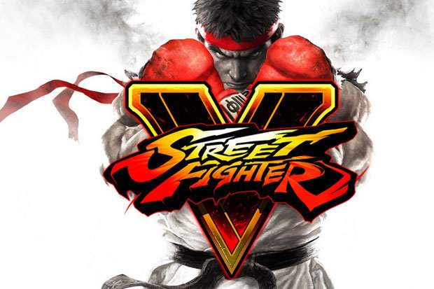

**Contents**

Getting Started ………………………… 2

Story ………………………………………… 2

Characters ………………………………. 10

Controls …………………………………… 3

Rules of Combat ………………………. 5

Game Modes ……………………………. 9

Credits ……………………………………… 11

**Getting Started**

Vic 20 System

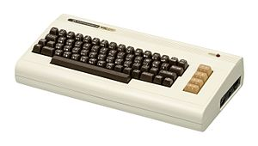

To load the game insert the SD card into the vic-20. On screen type in “Street fighter.out load 8” (without quotes) wait for the game to be loaded in. Then type “run”.

[Screen shots of the commands on the vic-20]

**Story**

The Tournament Begins

**Characters**

|  |  |
| --- | --- |
| **Ryu** | A lone-wolf street fighter who has further honed the techniques taught by his master Gouken through intensive daily training. Many fighters have been drawn to and inspired by his lifestyle and strength. Ryu now travels the world in order to become a “True Martial Artist”, but soon finds himself caught up in a plot to exploit his impressive powers. |

|  |  |
| --- | --- |
| **Ken** | Ken trained with Ryu, who quickly became his closest friend and greatest rival. Ken is the heir apparent to the largest conglomerate in the U.S., the Masters Family. Due to the new life now growing within his wife, Ken is hesitant to take Ryu up on his latest challenge, but Eliza herself persuades him to enter the tournament. |

**Chun-Li**

**Controls**

**Vic-20 key layout**

**Buttons for moving**

Left

Right

Jump

Crouch

**Buttons for actions**

Punch

Kick

block

**Rules of Combat**

**Match Setup**

Three round matches. The first fighter to win two rounds is the winner.

**Winning Rounds**

A single round lasts for a maximum of 99 seconds on the timer. Reduce your opponent’s health meter to 0 within that time for a win by KO. If time runs out, then the fighter with the most health remaining will be declared the winner.

**A draw – how to we want to handle this**

A draw occurs when both fighter’s health falls to 0 at the same time or their remaining health is the same when the time runs out. If the final round of a match ends in a draw, then it is game over.

**The Game Screen**

**[Screen Shot of the Game]**

1 – Points

2 – Health bar

3 – Timer

4 – Win Markers

5 – Character Name

**Game Modes**

**Arcade Mode**

In this mode, you select on character then fight through a series of CPU opponents. There are ?? levels of CPU character difficulty, from [EASIEST] up to [HARDEST]. If you are defeated along the way, the game is over.

**2 Player Mode**

In this mode, two human players can select their characters and then fight against each other.

**Credits**